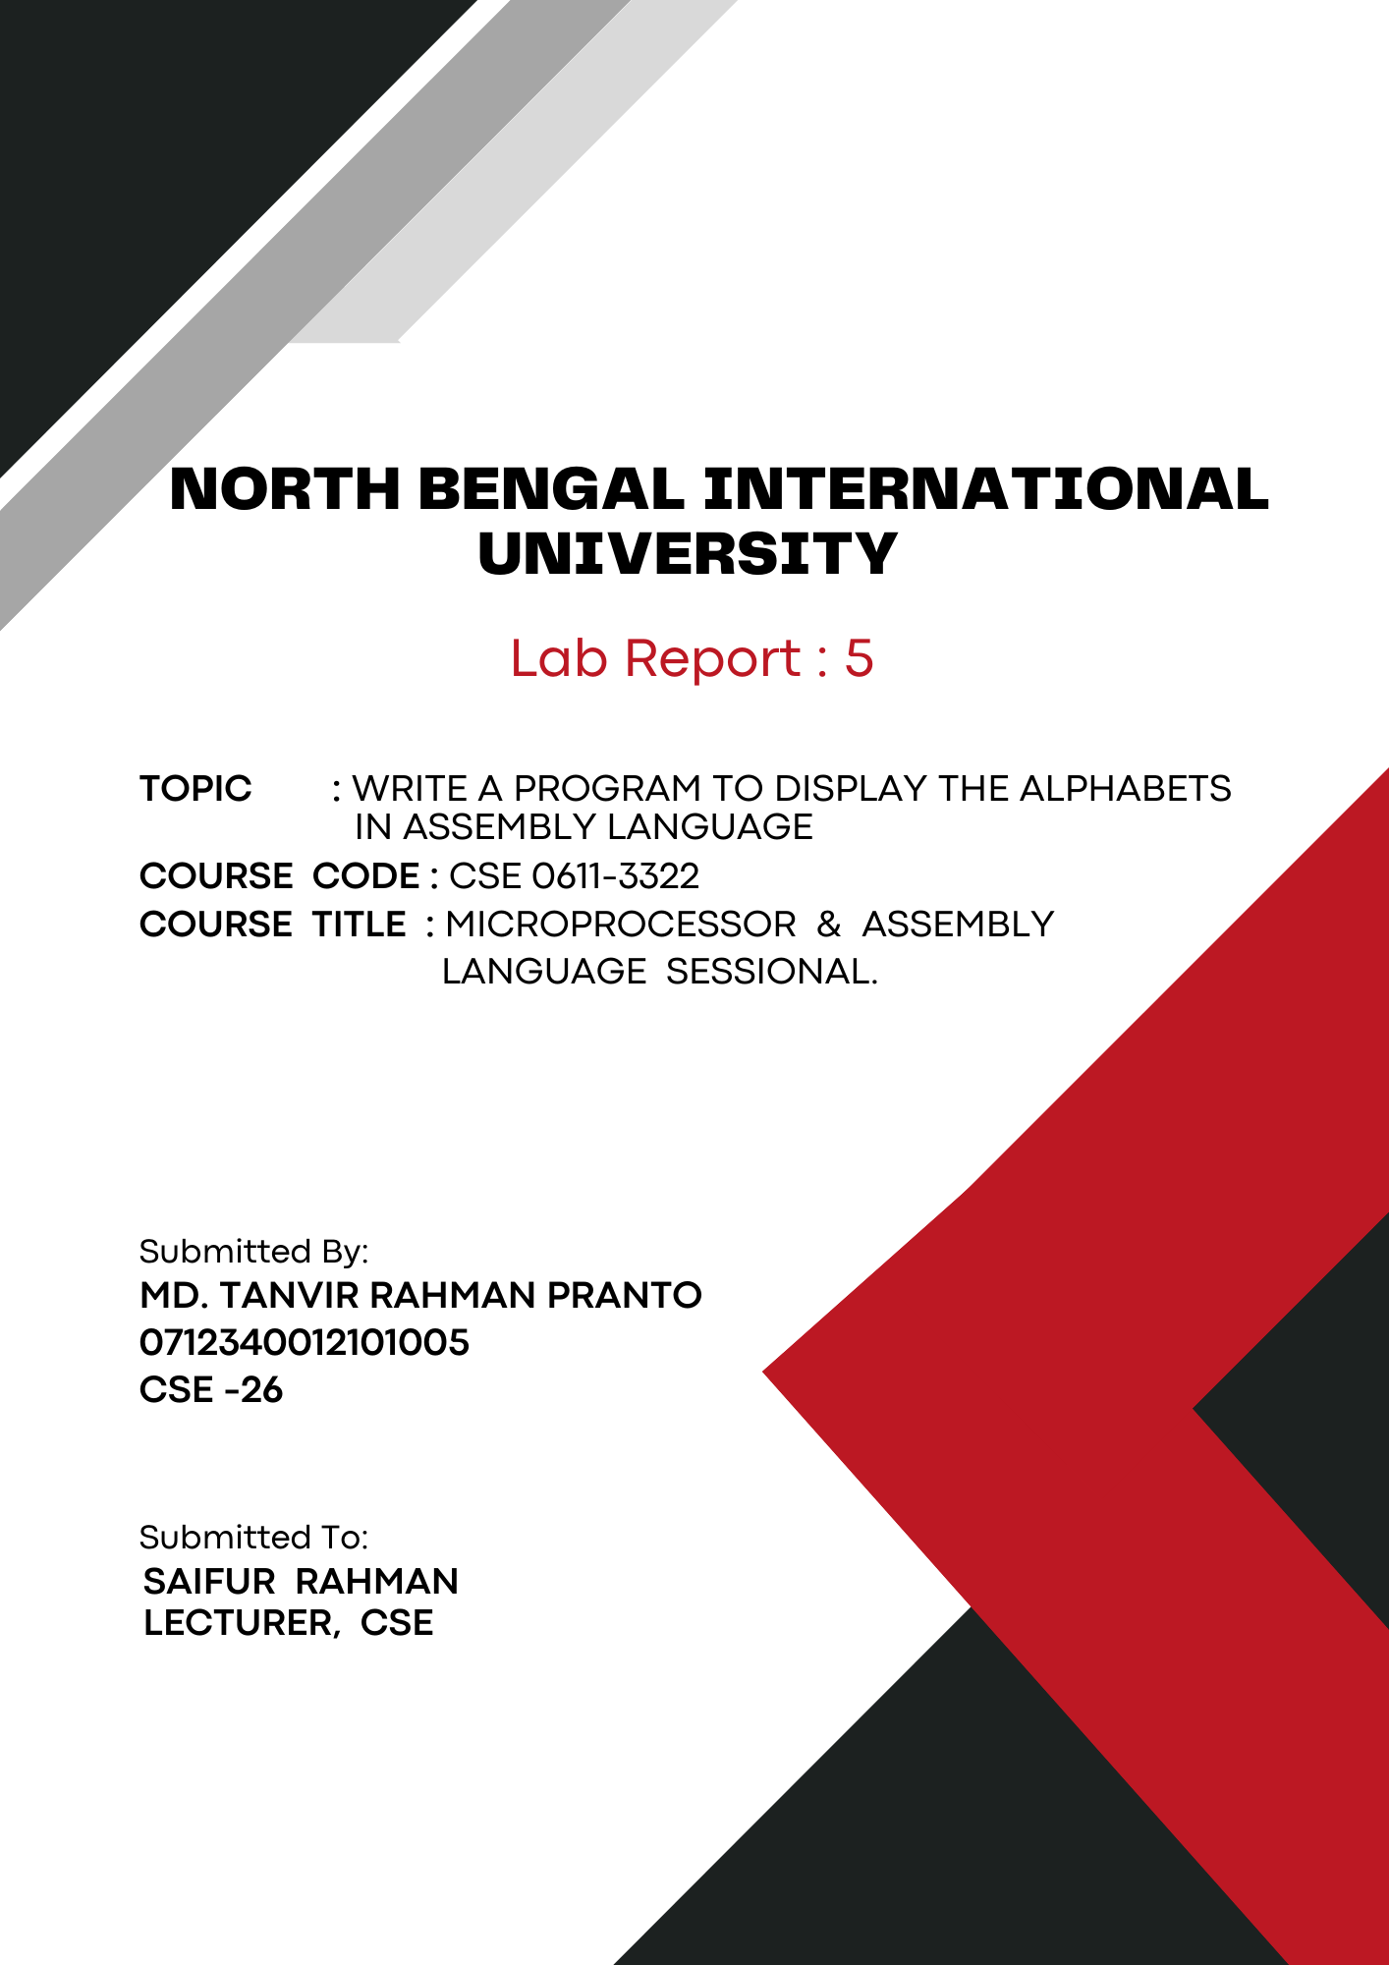
1

Theory: Assembly language is a low-level, human-readable programming language. It uses symbols instead of binary, mapping directly to machine instructions for specific architectures. It's ideal for high-performance or hardware-specific tasks.

Printing Characters from 'a' to 'z' in Assembly Language:
This assembly language program prints the alphabet from 'a' to 'z'. It defines an initial character 'a' in the data segment and sets up the data segment register. The code then uses a loop to increment and display each character until it reaches 'z', utilizing DOS interrupt 21h for output. The loop runs 26 times, corresponding to the number of letters in the alphabet, and the program exits cleanly after completion.

Code:
.model small
.stack 100h

.data
alph db 'a' ; Define a variable with the initial value 'a'

.code
main proc
; Initialize data segment
mov ax, @data
mov ds, ax

; Setup for printing characters
mov ah, 2
mov dl, alph

; Loop to print the alphabet
mov cx, 26
level1:
int 21h
inc dl
loop level1

; Exit program
mov ah, 4ch
int 21h

main endp
end main

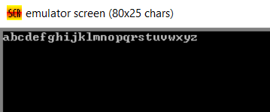
Output:

Conclusion: By practicing this code, we learn how to initialize and use the data segment, utilize loops for repetitive tasks, and handle character output using DOS interrupts. We also see how to increment values and effectively manage program flow with simple control structures in assembly language. This exercise reinforces fundamental concepts of low-level programming and direct hardware manipulation.

